DBMS LAB0
Anmol Keswani_ECS_D6-68
Aim: To study SQL commands, their uses, syntax, and install MySQL for database management experiments.
- What is SQL and its Use?
- SQL (Structured Query Language) is a standard programming language used to create, manage, and manipulate databases. It allows users to store, retrieve, update, and delete data in a database.
Uses of SQL:
- Creating and managing databases and tables.
- Inserting new data into tables.
- Retrieving required data using queries.
- Updating existing data.
- Deleting unwanted data.
- Controlling access and permissions to databases.
- Performing operations such as sorting, filtering, and joining data from multiple tables.

2. Describe all the different commands of SQL, mention use of it and syntax.
- SQL commands are generally divided into five main categories: DDL, DML, DQL, DCL, and TCL.

1. DDL – Data Definition Language
DDL commands are used to define and modify the structure of a database and its tables.
Command | Use | Syntax
CREATE | Creates a database or table. | CREATE TABLE table_name (column1 datatype, column2 datatype);
ALTER | Modifies the structure of an existing table. | ALTER TABLE table_name ADD column_name datatype;
DROP | Permanently deletes a table or database. | DROP TABLE table_name;
TRUNCATE | Deletes all records from a table while keeping its structure. | TRUNCATE TABLE table_name;
RENAME | Changes the name of a table. | RENAME TABLE old_name TO new_name;
Example:
CREATE TABLE Student (
RollNo INT,
Name VARCHAR(50),
Marks INT
);
2. DML – Data Manipulation Language
DML commands are used to insert, modify, and delete data stored in tables.
Command | Use | Syntax
INSERT | Adds new records to a table. | INSERT INTO table_name VALUES (value1, value2);
UPDATE | Modifies existing records. | UPDATE table_name SET column_name = value WHERE condition;
DELETE | Removes records from a table. | DELETE FROM table_name WHERE condition;

Example:
INSERT INTO Student VALUES (1, 'Rahul', 85);
UPDATE Student SET Marks = 90 WHERE RollNo = 1;
DELETE FROM Student WHERE RollNo = 1

3. DQL – Data Query Language
DQL is used to retrieve data from a database.

Command | Use | Syntax
SELECT | Retrieves data from one or more tables. | SELECT column1, column2 FROM table_name WHERE condition;

Example:
SELECT * FROM Student;
To retrieve students who scored more than 80:
SELECT Name, Marks
FROM Student
WHERE Marks > 80;

4. DCL – Data Control Language
DCL commands are used to control access and permissions in a database.
Command | Use | Syntax
GRANT | Gives privileges to a user. | GRANT privilege ON database_name.table_name TO user_name;
REVOKE | Removes privileges from a user. | REVOKE privilege ON database_name.table_name FROM user_name;

Example:
GRANT SELECT ON college.Student TO 'user1';
REVOKE SELECT ON college.Student FROM 'user1';

5. TCL – Transaction Control Language
TCL commands are used to manage transactions in a database.
Example:
UPDATE Student SET Marks = 95 WHERE RollNo = 1;
SAVEPOINT sp1;
UPDATE Student SET Marks = 100 WHERE RollNo = 1;
ROLLBACK TO SAVEPOINT sp1;
COMMIT;
Summary
Category | Full Form | Main Commands | Purpose
DDL | Data Definition Language | CREATE, ALTER, DROP, TRUNCATE, RENAME | Defines database structure
DML | Data Manipulation Language | INSERT, UPDATE, DELETE | Manipulates data
DQL | Data Query Language | SELECT | Retrieves data
DCL | Data Control Language | GRANT, REVOKE | Controls user access
TCL | Transaction Control Language | COMMIT, ROLLBACK, SAVEPOINT | Manages transactions

3. Write a step by step procedure to install MYSQL.
1. Go to Web Browser and search for ‘MySQL’ and go to the web page of MySQL , “MYSQL community downloads” —> “MYSQL installer for windows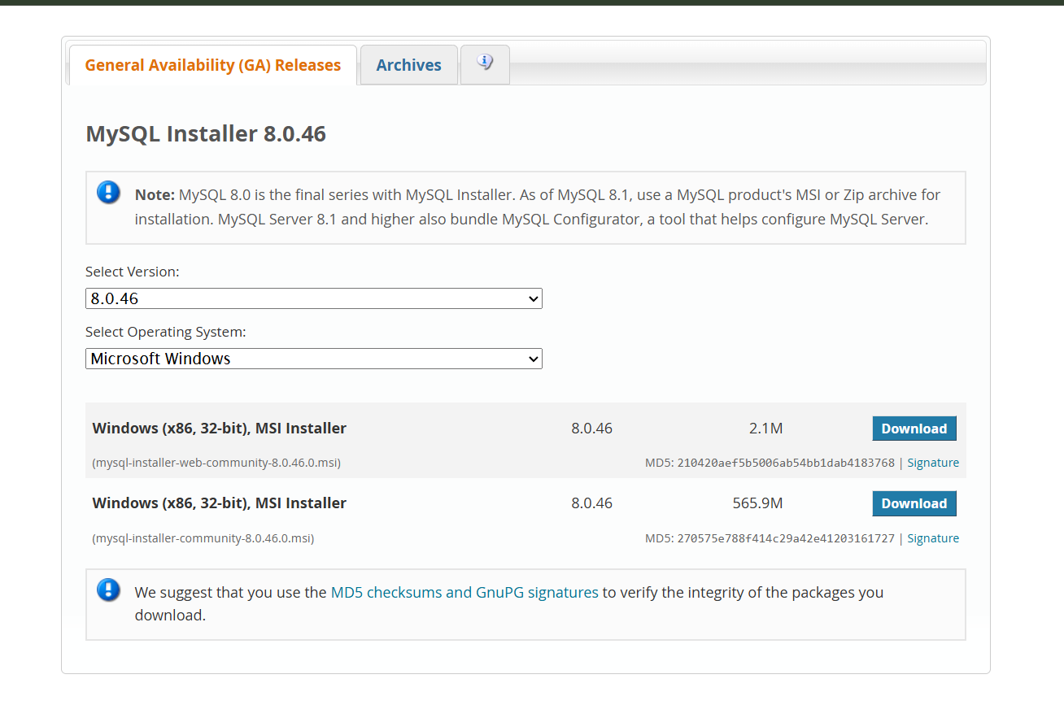
2. Run the Installer, for the setup type, select Custom. And “NEXT”.
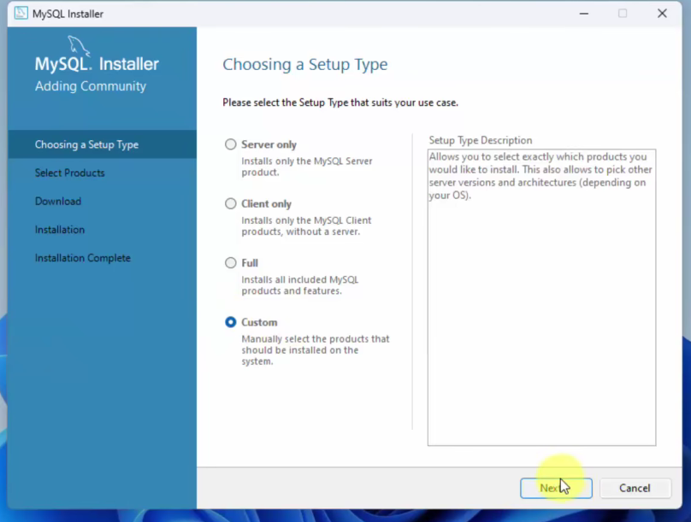

3. Select the Required Products
- Add the following products to the Products to be Installed section:
i) MySQL Server
ii) MySQL Workbench
iii) MySQL Shell

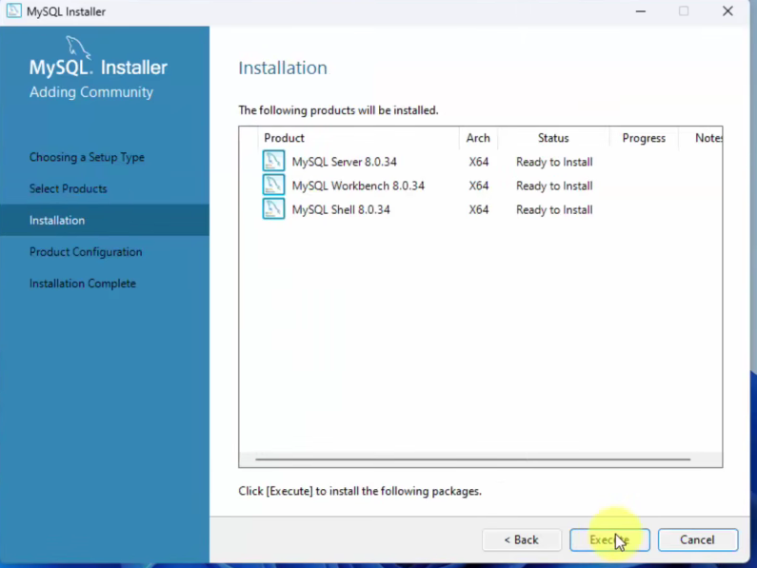

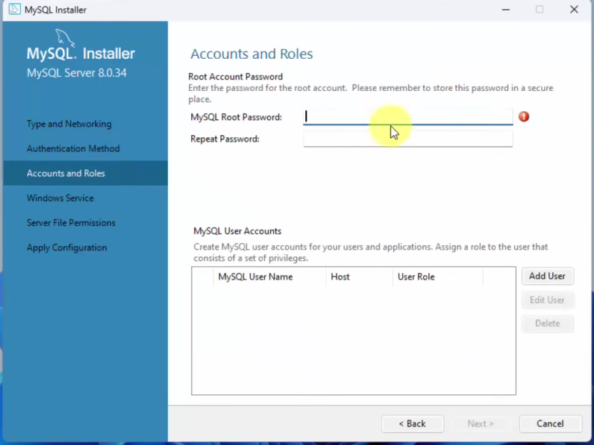
4. Configure Network Settings , Keep the default setting and keep clicking on next Then for authentication write a strong password, then click on next.

5. Keep clicking on NEXT , and then FINISH. Then , Set Environment Variables
- Copy the path of the MySQL bin folder (e.g., C:\Program Files\MySQL\MySQL Server\bin).
- Search for Environment Variables in the Windows Start menu.
- Under System Variables, select Path and click Edit.
- Click New, paste the copied path, and click OK.
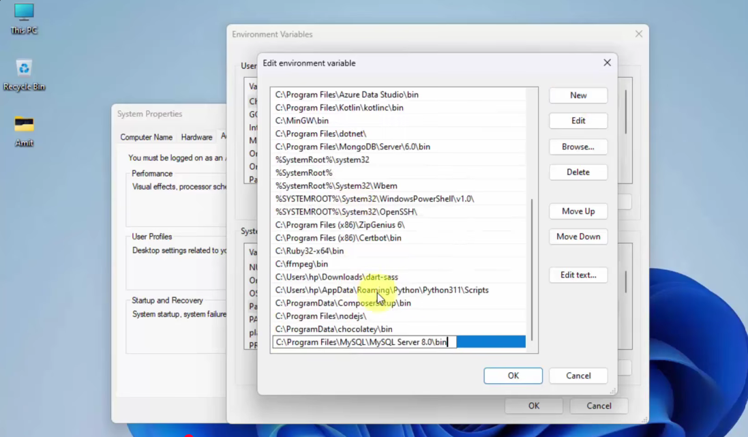
6. Verify the Installation
- Open Command Prompt (CMD).
- Type the following command: mysql --version
